

Dr. William, Wise inc.

2020-03-12

Dr. Wise

148 Maureen Manor Apt. 383, Brownland, OK 05876

Phone: 7206679820

Fax: 137625765

**Re:** Patricia, Mcgee

**PHN:** 5827508791

**Birthdate:** 10-Jan-1989

**Address:** PSC 5649, Box 7918, APO AE 96576

**Patient number:** 5118958953

To Whom It May Concern:

This is a medical letter to state the above patient is pregnant with expected delivery date of 17-Mar-2025. Hoping this information is satisfactory for your requirements.

Thank you.

Sincerely,

Dr. William, Wise

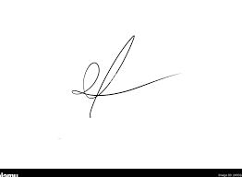

FRCS© NCMP

Clinical Assistant Professor, UBC

Department of Obstetrics and Gynecology SMH